EXTREMIST REVIEWER GROUPS IN ONLINE PRODUCT REVIEWS: IDENTIFICATION AND CHARACTERIZATION

*1Pothiganti Srilatha, 2Katangur Sandesh Reddy, 3Gaddam Barghav, 4Godugu Meenakshi, 5Mrs.N.Sindhuja*

*1,2,3,4Bachelor Degree,Cse, Jayamukhi Institute Of Technological Sciences,Narsampet, Warangal.*

*5Mrs.N.Sindhuja, Assistant Professor, Cse, Jayamukhi Institute Of Technological Sciences Narsampet, Warangal.*

**ABSTRACT:**

In the form of reviews, opinion spam is a common occurrence in online marketplaces. People are sometimes employed to write evaluations that are either extremely positive or extremely bad in order to promote or hinder a certain company. Frequently, this is carried out in groups.

Although several prior research made an effort to locate and analyse such opinion spam groups, nothing has been done to uncover those that target a brand as a whole rather than simply certain goods.

In order to write this post, we gathered reviews from the Amazon product review website and manually categorised 923 potential reviewer groups. Users who have evaluated a large number of brands together are grouped together when the groups are derived utilising frequent item set mining over brand similarities.

especially if they have reviewed several different brands' items together. We propose that eight factors particular to a (group, brand) pair determine the makeup of reviewer groups. To categorise potential candidate organisations as extremist organisations, we create a feature-based supervised model. We employ many classifiers to categorise a group based on the evaluations left by its members in order to evaluate whether the organisation exhibits indicators of extremism. The most effective classifier is a three-layer perceptron-based one.

To better understand the dynamics of brand-level opinion fraud, we continue to investigate the behaviours of such groups in-depth. These actions include maintaining ratings and review sentiment over time, as well as being consistent with review dates, confirmed purchases, and review sentiment. Surprisingly, we notice that many certified reviewers are expressing really strong opinions. Further research reveals ways to get over the current safeguards against unofficial incentives on Amazon.

**INTRODUCTION:**

Today's world, which is driven by online markets, depends heavily on review portals and websites to help consumers decide what to buy next.

It is a positive feedback loop; the more reviews, the more purchases. More reviews result from more purchases. According to Alice [1], the proprietor of online cosmetics retailer Elizabeth Mott, "the more purchases, the higher your rank in search and the more sales you get."

Undoubtedly, it is very conceivable that some people may submit evaluations that are not entirely true in an effort to sway the opinions of many consumers in their favour. These individuals either act alone or in groups. While particular critics pen such Reviews, whether positive or negative, do not significantly affect the general impression of a product but rather assist other consumers by outlining their own experiences. A stronger argument is made, but, when many people join forces to build a complex network, and as a result of the sheer volume of reviews (and other strategies, covered in Section VIII), they have a significant impact on the product's perception as a whole. The scope of such impact extends beyond reviews that contain opinion spam. Previous research [2] has demonstrated that 10%–15% of reviews simply repeat the initial reviews, therefore a false early review has an even greater potential for influence.

Every review website should be aware of this behaviour and take the necessary precautions to identify and/or prevent this prevalent kind of opinion spam.

This is a common instance of collective fraud behaviour when numerous users collaborate to target and sway a certain product through a business network. This is a less common occurrence, as most organisations operate using specific strategies to hide their collaboration.

However, as many of them are often controlled by a single organisation and some of these are financially or otherwise motivated, they have a number of targets for opinion junk mail which frequently shares certain similar traits in the form of reviews.

Using a reliable and extensive analytic approach, these traits may be used to better categorise them. According to [3], Amazon India has implemented a new policy that restricts the amount of product reviews that may be written in a day in order to avoid opinion spam.

We argue that certain organisations target brands in general and post severe ratings across several goods for a specific target brand in order to remain effective. This is a more extreme kind of opinion spam in which a brand is purposefully given extremely favourable or bad evaluations in an effort to elevate or denigrate them in the fierce online marketplace competition.

Studies have been done to identify these influence-peddling groups [4]–[6], but the phenomena of groups engaging in brand-based opinion spamming is still mostly unstudied. These brand-related actions need to be discussed in depth since they violate the evaluated sites' standard of conduct because they negatively distort the brand-based competition and provide some businesses inherent advantages.

**RELETED WORK:**

The present literature is split into two categories by us: general research on e-commerce services and false review identification.

General Studies on E-Commerce Reviews:

Numerous research have been done on mining internet reviews and categorising them according to user sentiment [8]–[11].

Reviews have also been widely employed in the creation and improvement of recommendation systems [12] through [15] as well as in the extraction of product features [16] through [18]. The usefulness of product reviews in justifying the recommendations made by a recommendation system has also been demonstrated by another research [19]. With the emergence of Web 2.0, Pang et al. [20] demonstrated how reviews progressed as an essential step in the decision-making process and looked at them from a retrieval viewpoint. Since it may be challenging for buyers to sift through mountains of reviews, researchers have looked at ways to summarise reviews based on user sentiment [21] and other characteristics [22]–[24] as well. These studies fall under the general category of opinion summarization.

These studies collectively shown the importance of product reviews as a tool for assessing a product's quality. In addition, reviews are crucial for preserving a brand's online reputation, according to several marketing studies. [25], [26].

A review often includes a star rating that affects the total ratings of a product, but it has more of an impact when people read it. People only read reviews when they believe them to be useful, which can happen for a variety of reasons, including the length of the review, the star rating, the readability, and other factors. [27], [28]. Numerous initiatives have been made to determine what makes a review beneficial to readers.

]. Based on these findings, efforts have been made to develop systems that may suggest reviews to users [31] by forecasting their perceived value.

All of these studies emphasise that review extremity is a crucial component for determining the impact achieved by the reviews, which is an essential issue to notice.

Numerous studies have been conducted to determine how review extremity impacts users [32–34] and the relationship between a reviewer's attitude and the star ratings they provide [35].

An extreme review offers immediate confirmation for experiential items, such as films and novels, whereas a moderate review can result from neutrality or ambivalence [36], [37], and may be helpful for consumers seeking in-depth knowledge [32]. Moderate evaluations have been seen to impact "brand attitude" [27]. The work as a whole suggests reviews of individual products are extreme, which has an impact on the business as a whole. We try to comprehend extreme reviews at the brand level and link it to organisations that participate in the same.

B. Research on False Reviews

Reviews are such a powerful tool, thus it makes sense that there are a lot of unethical practises taking place in the review industry. Various initiatives have been made to identify and fully comprehend these practises, which are often referred to as opinion spam.

Three major categories may be used to categorise these investigations.

1. Research on reviews: Jindal and Liu [38] pioneered the detection of bogus reviews. They discussed the issue of opinion spam and examined three types of online reviews: untruthful opinions, seller/brand-only reviews (where no products are mentioned), and nonreviews that used information that was almost identical as a sign of phoney reviews. Other research on the subject of detecting review-level spam focused on textual linguistic traits [39], handwritten rules [40], and combinations of author and review feature sets [41]. The same has also been given a probabilistic framework in [42]. Ott the researchers [39] utilised Amazon Mechanical Turk to create fabricated hotel evaluations, whereas Jindal and Liu [38] used data that was collected from Amazon and employed content duplicity as the source of truth. At a review, they both worked with features.
2. The role of brands was briefly discussed by Jindal et al. [40] and Li et al. [41], however the major emphasis was on bogus reviews rather than extreme reviews.
3. 2) Research on Reviewers: Research on reviewer fraud takes into account rating behaviour [7], [43], and trust ratings based on a relationship graph between reviewers, reviews, and retailers [44]. Other research [45]–[47] revealed several additional techniques that utilise behavioural footprints to detect fraudulent reviewers, including popularity spikes and Bayesian approaches. It should be noted that Wang et al. [44] pioneered the use of a review graph for locating such spammers.
4. Mukherjee and others [45] attempted to elucidate the attributes utilised by Yelp filters to identify anomalous behaviours and found that users who wrote fraudulent reviews had behavioural traits and psychological patterns of overusing popular phrases.
5. Mukherjee et al. [46] and Fei et al. [47] used techniques like loopy belief propagation on modelled Markov random fields and Bayesian modelling of spamicity as latent behaviour. However, in all of the methods, the signs of a fake reviewer were more frequently found in very positive or strongly negative reviews than in moderate reviews [43], especially when analysing a reviewer's rating behaviours.
6. This would suggest that opinion spam and extremism in reviews are connected, although this angle hasn't been fully investigated.
7. pleaded but.
8. 3) Research on Reviewer Groups: Fraud reviewer groups have a more negative and subtle impact than individual fraud reviewers. The problem of manual labelling was addressed by taking into account a team of reviewers rather than a single reviewer. According to Mukherjee et al. [4], labelling a group of reviewers is much simpler than labelling a single review. Other intriguing research that employ metadata to categorise various elements on e-commerce sites include [5] and [6], which concurrently classify users, reviews, and items.
9. a fully unsupervised model was put up to find group collusion. Numerous graph-based techniques have moreover demonstrated the capacity to concurrently identify spam reviewers and spam reviews [5]. The reviewer graph was expanded by Wang et al. [50] and Dhawan et al. [7] to identify collusive users, or a transient group of users who collaborate to spam.
10. Once more, no research has been done on the phenomena of extremism at a group level, particularly in relation to a brand since extremism eventually influences "brand attitudes."

**EXISTING SYSTEM:**

* Sentiment analysis can be conducted on three different levels: review-level, sentence-level, and phrase-level.
* Review-level analysis and sentence-level analysis attempt to classify the sentiment of a whole review to one of the predefined sentiment polarities, including positive, negative and sometimes neutral.
* While phrase-level analysis attempt to extract the sentiment polarity of each feature that a user expresses his/her attitude to the specific feature of a specific product.
* Zhang et al.propose a self-supervised and lexicon-based sentiment classification approach to determine sentiment polarity of a review that contains both textual words and emoticons. And they use sentiment for recommendation.

Lee et al.propose a recommender system using the concept of Experts to find both novel and relevant recommendations. By analyzing the user ratings, they can recommend special experts to a target user based on the user population.

**PROPOSED SYSTEM:**

* We propose a sentiment-based rating prediction method in the framework of matrix factorization. In our work, we make use of social users’ sentiment to infer ratings.
* First, we extract product features from user reviews. Then, we find out the sentiment words, which are used to describe the product features. Besides, we leverage sentiment dictionaries to calculate sentiment of a specific user on an item/product.
* The main contributions of our approach are as follows:
* We propose a user sentimental measurement approach, which is based on the mined sentiment words and sentiment degree words from user reviews.
* We make use of sentiment for rating prediction. User sentiment similarity focuses on the user interest preferences. User sentiment influence reflects how the sentiment spreads among the trusted users. Item reputation similarity shows the potential relevance of items.

We fuse the three factors: user sentiment similarity, interpersonal sentimental influence, and item reputation similarity into a probabilistic matrix factorization framework to carry out an accurate recommendation. The experimental results and discussions show that user's social sentiment that we mined is a key factor in improving rating prediction performances

**RESULT:**

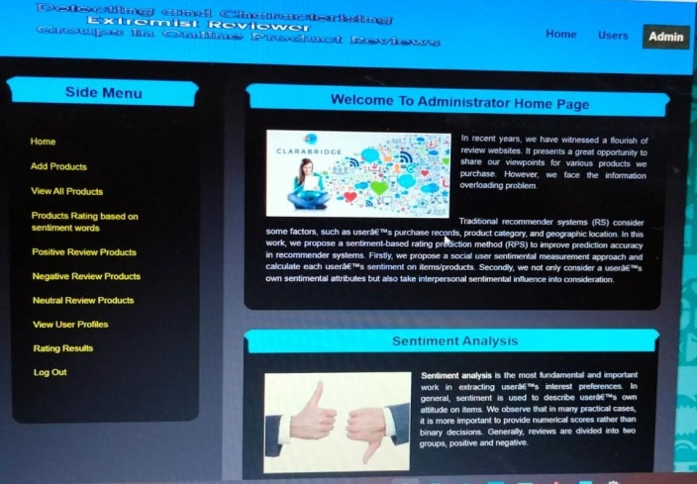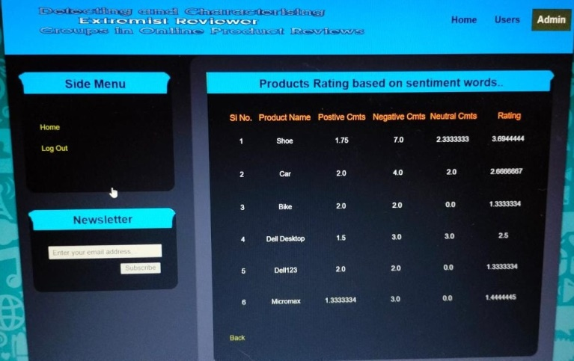

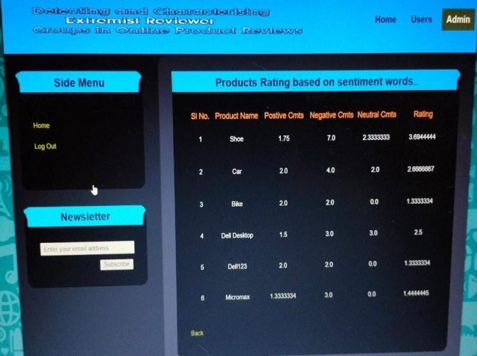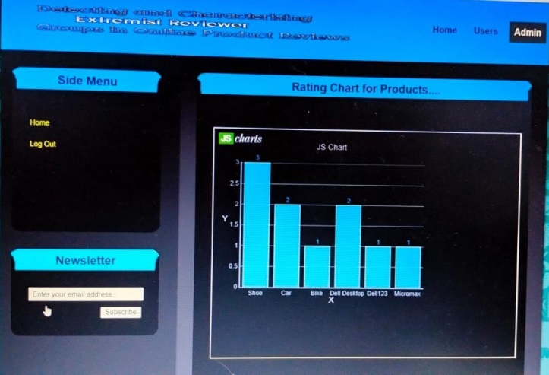

**CONCLUSION:**

In this essay, we covered a new type of opinion spam when spammers submit irrational reviews of businesses in an effort to alter public perceptions of those brands as a whole. These organisations are frequently a part of a sophisticated business web that has the power to affect the general rating and relevancy of a number of businesses on review platforms. This article is the first step in tying extremism in reviews to brand-level group activity, which reveals crucial information about market operations. With the use of these insights, a better suggestion might be made using internet reviews.

Extremist groups were found by analysing their activities as a group based on multiple attributes, utilising a supervised learning approach based on a ground truth of manually annotated labels, and retrieving a collection of potential spam groups using FIM. Then, we divided groups into extreme and moderate categories and evaluated the accuracy of several categorization techniques.

After identifying these groups, we carefully studied their behaviours to learn more about the phenomena and the general patterns of how these groups approach these companies. Additionally, we made the algorithms and annotated data set available for further research.

**REFERENCES:**

[1] A. Kim. (2017). That review you wrote on Amazon? Priceless. [Online]. Available: https://www.usatoday.com/story/tech/news/ 2017/03/20/review-you-wrote-amazon-pricess/99332602/

[2] E. Gilbert and K. Karahalios, “Understanding deja reviewers,” in Proc. ACM Conf. Comput. supported Cooperat. Work (CSCW), 2010, pp. 225–228, doi: 10.1145/1718918.1718961.

[3] Amazon.in. (2018). Review Community Guidelines. [Online]. Available: https://www.amazon.in/gp/help/customer/display.html?nodeId= 201929730

[4] A. Mukherjee, B. Liu, and N. Glance, “Spotting fake reviewer groups in consumer reviews,” in Proc. 21st Int. Conf. World Wide Web (WWW), 2012, pp. 191–200.

[5] Y. Lu, L. Zhang, Y. Xiao, and Y. Li, “Simultaneously detecting fake reviews and review spammers using factor graph model,” in Proc. 5th Annu. ACM Web Sci. Conf. (WebSci), 2013, pp. 225–233.

[6] S. Rayana and L. Akoglu, “Collective opinion spam detection: Bridging review networks and metadata,” in Proc. 21th ACM SIGKDD Int. Conf. Knowl. Discovery Data Mining (KDD), 2015, pp. 985–994.

[7] S. Dhawan, S. C. R. Gangireddy, S. Kumar, and T. Chakraborty, “Spotting collective behaviour of online frauds in customer reviews,” 2019, arXiv:1905.13649. [Online]. Available: [http://arxiv.org/abs/1905. 13649](http://arxiv.org/abs/1905.%2013649)

[8] K. Dave, S. Lawrence, and D. M. Pennock, “Mining the peanut gallery: Opinion extraction and semantic classification of product reviews,” in Proc. 12th Int. Conf. World Wide Web (WWW), 2003, pp. 519–528.

[9] B. Pang, L. Lee, and S. Vaithyanathan, “Thumbs up? Sentiment classification using machine learning techniques,” in Proc. Conf. Empirical Methods Natural Lang. Process., 2002, pp. 79–86.

[10] K. Mouthami, K. N. Devi, and V. M. Bhaskaran, “Sentiment analysis and classification based on textual reviews,” in Proc. Int. Conf. Inf. Commun. Embedded Syst. (ICICES), Feb. 2013, pp. 271–276.

[11] Q. Ye, Z. Zhang, and R. Law, “Sentiment classification of online reviews to travel destinations by supervised machine learning approaches,” Expert Syst. Appl., vol. 36, no. 3, pp. 6527–6535, Apr. 2009.

[12] M. Chelliah and S. Sarkar, “Product recommendations enhanced with reviews,” in Proc. 11th ACM Conf. Recommender Syst., Aug. 2017, pp. 398–399.

[13] L. Chen and F. Wang, “Preference-based clustering reviews for augmenting e-commerce recommendation,” Knowl.-Based Syst., vol. 50, pp. 44–59, Sep. 2013.

[14] J. Feuerbach, B. Loepp, C.-M. Barbu, and J. Ziegler, “Enhancing an interactive recommendation system with review-based information filtering,” in Proc. IntRS@RecSys, 2017, pp. 10–55.

[15] A. Almahairi, K. Kastner, K. Cho, and A. Courville, “Learning distributed representations from reviews for collaborative filtering,” 2018, arXiv:1806.06875. [Online]. Available: <http://arxiv.org/abs/1806.06875>

[16] A.-M. Popescu and O. Etzioni, “Extracting product features and opinions from reviews,” in Proc. HLT, 2005, pp. 339–346.

[17] B. Liu, M. Hu, and J. Cheng, “Opinion observer: Analyzing and comparing opinions on the Web,” in Proc. 14th Int. Conf. World Wide Web (WWW), 2005, pp. 342–351.

[18] M. Hu and B. Liu, “Mining opinion features in customer reviews,” in Proc. AAAI, 2004, pp. 755–760.

[19] T. Donkers, B. Loepp, and J. Ziegler, “Explaining recommendations by means of user reviews,” in Proc. 1st Workshop Explainable Smart Syst. (ExSS), 2018. [Online]. Available: <http://ceur-ws.org/Vol-2068/exss8.pdf>

[20] B. Pang et al., “Opinion mining and sentiment analysis,” Found. Trends Inf. Retr., vol. 2, nos. 1–2, pp. 1–135, 2008.

[21] M. Hu and B. Liu, “Mining and summarizing customer reviews,” in Proc. ACM SIGKDD Int. Conf. Knowl. Discovery Data Mining (KDD), 2004, pp. 168–177.

[22] G. Somprasertsri and P. Lalitrojwong, “Mining feature-opinion in online customer reviews for opinion summarization,” J. UCS, vol. 16, no. 6, pp. 938–955, 2010.

[23] L. Zhuang, F. Jing, and X.-Y. Zhu, “Movie review mining and summarization,” in Proc. 15th ACM Int. Conf. Inf. Knowl. Manage. (CIKM), 2006, pp. 43–50.

[24] S. Pecar, “Towards opinion summarization of customer reviews,” in Proc. Student Res. Workshop (ACL), 2018, pp. 1–8. [Online]. Available: <https://www.aclweb.org/anthology/P18-3001>

[25] N. N. Ho-Dac, S. J. Carson, and W. L. Moore, “The effects of positive and negative online customer reviews: Do brand strength and category maturity matter?” J. Marketing, vol. 77, no. 6, pp. 37–53, Nov. 2013.

[26] P. K. Chintagunta, S. Gopinath, and S. Venkataraman, “The effects of online user reviews on movie box office performance: Accounting for sequential rollout and aggregation across local markets,” Marketing Sci., vol. 29, no. 5, pp. 944–957, Sep. 2010.

[27] S. Mudambi and D. Schuff, “Research note: What makes a helpful online review? A study of customer reviews on Amazon. com,” MIS Quart., vol. 34, pp. 185–200, Mar. 2010.

[28] G. Yin, L. Wei, W. Xu, and M. Chen, “Exploring heuristic cues for consumer perceptions of online reviews helpfulness: The case of Yelp.com,” in Proc. PACIS, 2014, Art. no. 52. [Online]. Available: <https://aisel.aisnet.org/pacis2014/52/>

[29] S.-M. Kim, P. Pantel, T. Chklovski, and M. Pennacchiotti, “Automatically assessing review helpfulness,” in Proc. Conf. Empirical Methods Natural Lang. Process. (EMNLP), 2006, pp. 423–430. [Online]. Available: <http://dl.acm.org/citation.cfm?id=1610075.1610135>

[30] Y. Wang, J. Wang, and T. Yao, “What makes a helpful online review? A meta-analysis of review characteristics,” Electron. Commerce Res., vol. 19, no. 2, pp. 257–284, Jun. 2019, doi: 10.1007/s10660-018-9310-2.

[31] M. Salehan, M. Mousavizadeh, and M. Koohikamali, “A recommender system for online consumer reviews,” Assoc. Inf. Syst., Fort Worth, TX, USA, Tech. Rep. 12, 2015. [Online]. Available: <https://aisel.aisnet.org/icis2015/proceedings/DecisionAnalytics/12/>

[32] M. Eisend, “Two-sided advertising: A meta-analysis,” Int. J. Res. Marketing, vol. 23, no. 2, pp. 187–198, 2006.

[33] P. A. Pavlou and A. Dimoka, “The nature and role of feedback text comments in online marketplaces: Implications for trust building, price premiums, and seller differentiation,” Inf. Syst. Res., vol. 17, no. 4, pp. 392–414, Dec. 2006.

[34] C. Forman, A. Ghose, and B. Wiesenfeld, “Examining the relationship between reviews and sales: The role of reviewer identity disclosure in electronic markets,” Inf. Syst. Res., vol. 19, no. 3, pp. 291–313, Sep. 2008.